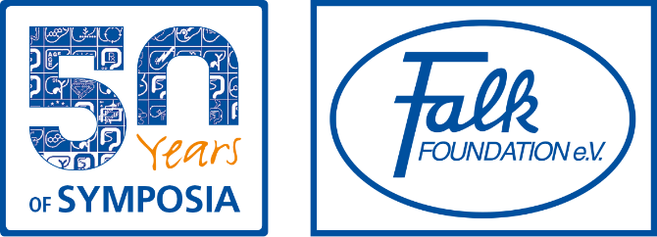

**August 2017**

**HALF A CENTURY OF EXCELLENCE IN PROMOTING MEDICAL AND SCIENTIFIC EXCHANGE**

**2017 marks fifty years of international Falk Symposia, an event which is now globally recognised for excellence in gastroenterology and hepatology training and debate.**

**The first Symposium, dedicated to hepatology, was held in Freiburg in 1967 and was attended by over 800 participants from 17 different countries. Since then, over 130,000 clinicians, researchers and other health care professionals have attended more than 200 events in countries including China, Australia, Europe and the USA. Attendees have enjoyed not just first class talks from world leading specialists across a broad spectrum of topics, but workshops, valuable discussions and networking opportunities as well.**

**Right from the start, the content and the programme for each event were developed independently by an external committee of experts and in 1978, The Falk Foundation was established in order to reinforce that principle of the neutrality. Each symposium is directed by a distinguished scientific organizer who, with the aid of the committee, puts together the content and invites the speakers - all pioneers in their fields - and the high quality and neutrality of the science is a major factor in the continuing success of the Symposia.**

**Support is also provided for the next generation. Each event includes a poster session providing young scientists with the chance to present the results of their research to a specialist audience. An independent committee awards prizes to the best posters.**

**To ensure that the Symposium reaches the widest possible audience, and as a service for attendees, a summary of the major topics of the symposium is provided in *GastroScope*. This publication, available in hard copy or online, also includes interviews with Symposium participants and background information. In addition, since October 2016, review articles summarizing presentations on related topics have been produced after each Symposia, with the first article to appear in an international peer-reviewed journalshortly.**

**Future years will doubtless see Falk Foundation Symposia continuing to adhere to the same successful philosophy built around neutrality of science and medicine, together with lively scientific exchange. All with the overall aim of encouraging innovation and further development in the gastroenterology and hepatology therapy areas.**

**Ends**

